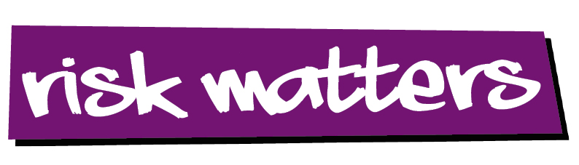
Suncare Guidance – Protecting Children – Under 5s (May 2025)
The 5 S’s of Sun SafetyUN SAFETY:
- SLIP on a t-shirt
- SLOP on SPF 30+ (preferably 50+), broad spectrum UVA sunscreen
- SLAP on a broad brimmed hat (or Legionnaires style cap)
- SLIDE on quality sunglasses
- SHADE from the sun whenever possible

Use the Five S's of Sun Safety to help prevent skin cancer (skcin.org)

All children should enjoy the sunshine whilst being protected from the dangers of too much sun/UV rays. Children’s safety and welfare in hot weather is essential and staff should work closely with parents to ensure all appropriate cream and clothing is provided, where possible.

From March to October, follow guidance from the weather and UV level reports (NHS), and use the following procedures to keep children safe and healthy in the sun:
CLOTHING
- Ensure children are dressed in suitable clothing and that shoulders are covered during warmer months. Ideally light-weight cotton clothing for their children suitable for the sun, with long sleeves and long legs. Sunglasses are optional.
- Ensure children wear their sun hat outdoors when UV levels reach 3 or above, preferably Legionnaires design (i.e. with an extended back and side to shield children’s neck and ears from the sun) to provide additional protection
- Make available additional/spare sun hats for all outdoor play/activities, in the event that parents/carers are unable to provide one.
- Babies under 6 months should be kept out of direct strong sunlight and appropriate sunshades should be used when children are in prams or buggies.

SUNCREAM
- Children should have their own labelled high factor sun cream with prior written consent. This enables children to have sun cream suitable for their own individual needs.
- Ensure sunscreen is applied when UV levels reach 3 or above, before periods of outdoor play / activities and reapplied at least every 2 hours when required.
- A minimum Sun Protection Factor 30 (SPF 30), BUT ideally SPF50, where possible.
- Suncream should be labelled ‘Broad-Spectrum’ to provide both UVA and UVB protection and labelled with a UVA symbol (minimum 4 stars)
- Apply generously to exposed skin, 20 minutes before going outdoors when UV levels reach 3 or above.
- Adults should apply cream and to avoid spread of infection, either wash hands in between each application or wear a latex free glove which should be replaced between each application
- ALL sunscreens should be reapplied at least every 2 hours and more often if sweating/towelling/playing in water.
- Sunscreen should be stored in a cool, dry, accessible place.
- Check expiry dates as sunscreen becomes less effective over time. If an expiration date is not displayed, look for an open jar symbol which will have a number next to it (i.e. 9M or 12M) - that’s the number of months you can safely use the sunscreen after opening.
- Work with parents to decide and agree on suitable precautions to protect children from burning, including more sensitive skin types and those that may be more tolerant to the sunshine, e.g. black and/or Asian colouring.

HYDRATION

- Ensure children are kept hydrated with drinks, and have open access to water at room temperature, available and encouraged regularly throughout the day, especially during warmer weather and physical activity.

RISK ASSESSMENT (UV Levels/Shaded areas)

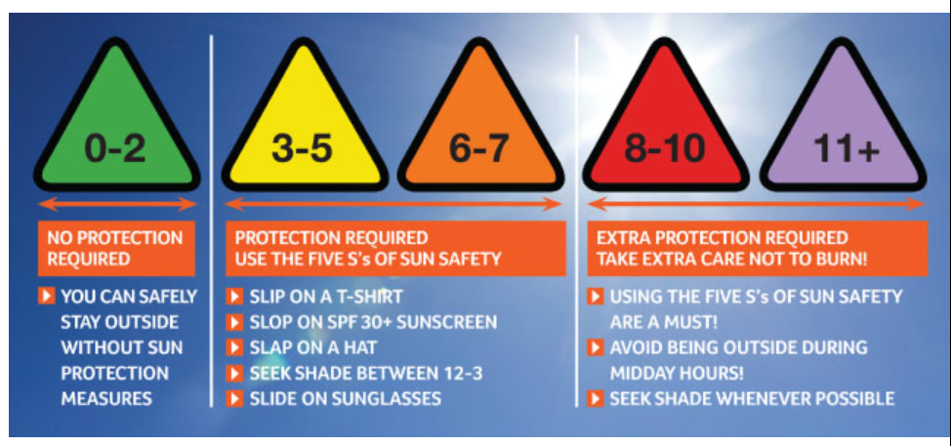
The Solar UV Forecast - Check the latest UV Forecast with Skcin Further info re UV
Edinburgh (Edinburgh) weather - Met Office UV

- Severe sunburn in childhood can lead to the development of malignant melanoma (the most dangerous type of skin cancer) in later life.
- Risk assess daily, particularly during warmer months, to monitor and limit time children spend outdoors according to UV levels and during peak UV hours (11am - 3pm).
- Identify and provide shaded areas outdoors where children can congregate for outdoor play and activities.
- Conduct shade assessments to consider future needs and identify opportunities to find and improve shade solutions, if necessary.
- Children should, ideally, play in the shade as much as possible when UV levels reach 3 or above, particularly between peak UV hours (11am-3pm).

PROMOTION WITH PARENTS

- Provide parents and carers with sun safety and skin cancer awareness information to promote support and raise awareness of prevention and early detection.
- Parental Permission needed before applying the cream appendix-3-early-years-medication-forms (edinburgh.gov.uk)
- Parents should provide labelled ‘Broad-Spectrum’ to provide both UVA and UVB protection and labelled with a UVA symbol (minimum 4 stars)
- Where parents are unable to provide the setting should provide above.
- Parents/carers should apply suncream before the child arrives at ELC.

VITAMIN D
Sunlight is important for the body to receive vitamin D. We need vitamin D to help the body absorb calcium and phosphate from our diet. These minerals are important for healthy bones, teeth and muscles.
Our body creates vitamin D from direct sunlight on our skin when we are outdoors.
Children under 3 are entitled to free Vitamin D (10 micrograms per day) via their Health Visitor or this may be sourced free via a local pharmacy (minor ailments). The first pack is currently provided free on discharge from maternity unit.
Sunscreen and sun safety - NHS (www.nhs.uk)
Vitamins for children - NHS (www.nhs.uk) (re Vitamin D)
appendix-3-early-years-medication-forms (edinburgh.gov.uk) Permission slip
Sun protection for Children, Babies & Toddlers (skcin.org) UV information and more

